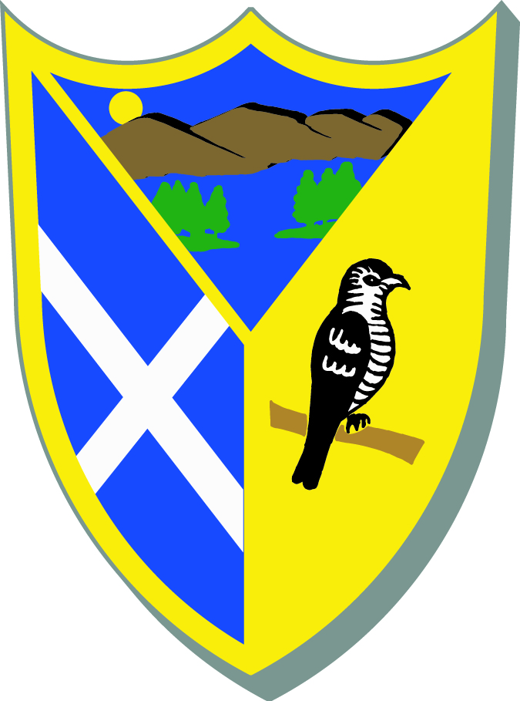
Dear Parent/Carer

During your child’s life at the school we may wish to take photographs of activities that involve your child. The photographs may be used for displays, publications and on a school managed web/social networking site by the school or, with school permission, others associated with the school.

Photography or filming will only take place with the permission of the Head teacher/manager, and under appropriate supervision. When filming or photography is carried out by the news media, children will only be named if there is a particular reason to do so (e.g. they have won a prize), and home addresses will never be given out. Images that might cause embarrassment or distress will not be used nor will images be associated with materials or issues that are considered sensitive.

From time to time, our school may be visited by the media who will take photographs or film footage of a newsworthy event in the school. Unless your child is part of a large group, it is likely that the media will require your child’s full name before the picture is printed. If you give your consent to this, you should be aware that these images may appear in local or national newspapers and world-wide on-line.

Before taking any images of your child, we need your permission. This permission will last for the whole of your child’s education at this school. Please answer the questions below, sign and date the form and return it to the establishment. You can ask to see images of your child held by the establishment. You may withdraw your consent at any time.

If you wish to attend establishment functions and take photography of your and other people’s children please take appropriate images, be sensitive to other people and try not to interrupt or disrupt concerts, performances and events.

Please read our Policy for the Use of Images of Children and indicate whether you agree to your child’s images being taken. You have the option to indicate whether or not you consent to your child’s images being taken and used for different purposes. You can withdraw your consent at any time by writing to the school.

Name of Child (block capitals)
Child’s date of birth
Name of parent or legal guardian (block capitals)
I have read the leaflet on the use of images of children and I agree to its provisions. Please give your consent by putting your initials next to each statement below.
I give my consent to images of my child being taken and used for official school purposes of promoting or publicising the school and events in accordance with the guidelines of the school policy for the duration of their time at the school |  | Please initial below
I give my consent to images of my child being used on the school website, on websites of those organisations permitted to use images by the school and school managed Social Network sites and I understand that these images will be available on the World Wide Web
I give my consent to images being used with full name in the newspaper
I do not give my consent to images being used with a full name in the newspaper
I give my consent to my child being included in any images taken by other parents or carers who wish to photograph or record school events in which their children are participating. All parents/guardians will be asked to sign an agreement for appropriate use of images they take during school events. Please see below. [Insert if school’s policy is to allow parents to take images]
I have read and understood the conditions of use on the back of this form
I agree that any photographic or video images I as a parent/guardian might take at school events will not be used inappropriately. [Insert if school’s policy is to allow parents to take images]
Signature of person responsible for the child:
Relationship to the child:
Date (Date/Month/Year):

